Dashboard page after login….

image place holders to be replaced by actual images/icons.

This document defines the admission flow for new student.

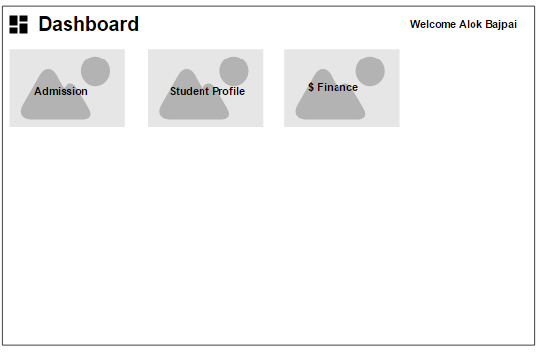

Admission journey will be started once user clicks on admission image as followes.

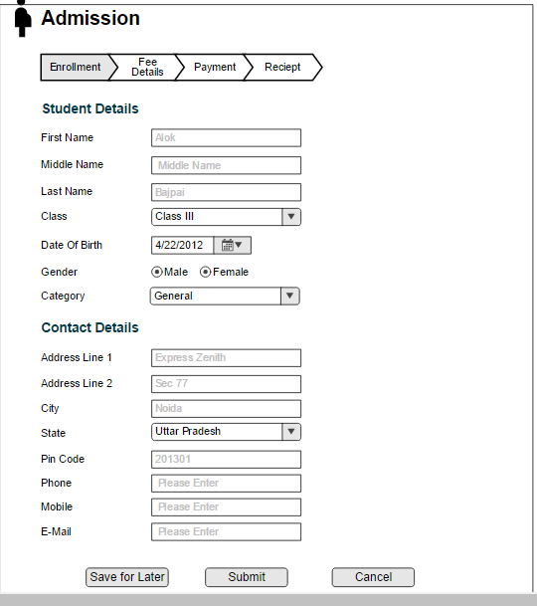

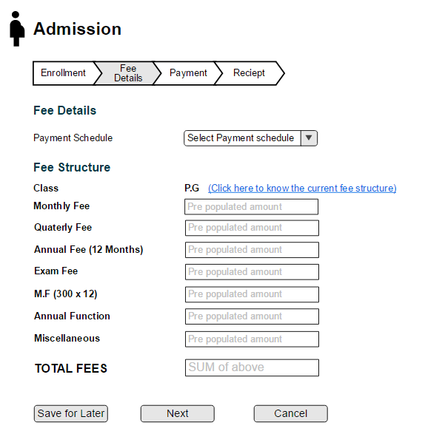

The Above fee page shall be appear only for classes P.G, L.K.G and U.K.G. There shall be a different fee page (Yet to be designed) for class 1 to 12ve because of different fee structure.

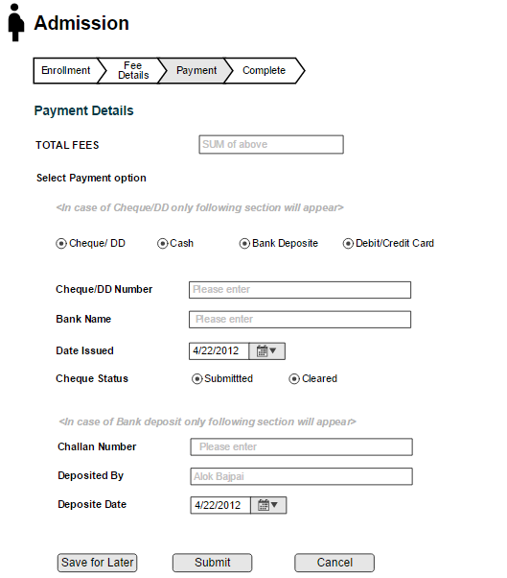

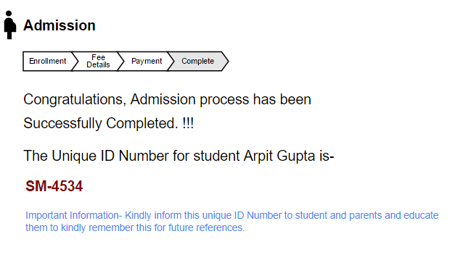

Following screen will appear when user clicks on Finance icon on dashboard

